PBARC Rotating Carousel Olfactometers



Preparing for an experiment:

1. Reserve dates and times to run an experiment.
2. A sign- up sheet/ calendar is located near the ecology lab door.
3. Prepare all chemical treatments in traps before entering the arena.
4. See rotor operation instructions below.
5. Do not put weight on the screen door handles while opening.
6. Do not lean or push on any of the screened walls of the olfactometer.
7. Clean up after your experiment is completed.
8. Clean up any spills with the proper cleaning solutions.
9. Sweep out debris and dead insects.
10. Report any problems, concerns or damage ASAP to Nick.

# Operation

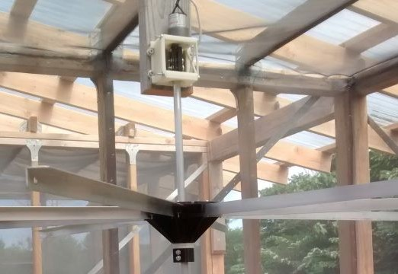

## The rotors

As seen in the picture above, each rotor is a wheel with 8 two-foot-long arms radiating from the center. The wheel engages with the shaft via a clutch (the white discs between the bottom clamp and the main wheel). If you lift the wheel from the center it will disengage the clutch and allow you to freely rotate it.

At the top of the shaft is a 1 RPM (approximate) motor directly connected via a coupler and an assembly attaching it to the cage. Caution: Pushing laterally on the shaft will put a lot of force on the attachment and likely break it.

## Hanging traps

The rotors are designed for lightweight sticky-panel traps such as Jackson Traps. They should be able to handle heavier traps including wet-traps such as McPhail Traps, but try to keep it light and exercise caution (extreme caution if lure might spill if the trap falls).

Each arm has a hole at the end for hanging traps. If a different orientation or more flexibility is needed, I suggest looping small cable ties through the holes and hanging from those.

## Turning the system on

The power and controls are located on the right side of the second cage. The black Line-X covered box is the power unit (see photo below), and should be switched on by flipping the on/off switch on the right up. This switch connects the batteries to both the rotors and the solar charger, so it should just be left on unless the olfactometer is going to be unused for a while. Directly above the on/off switch is a push-to-reset circuit breaker.

Each rotor is connected to its own switch located in the grey box (see photo below). The top switch controls the leftmost rotor, the bottom the rightmost. The switches have 3 positions, forward-off-reverse, so be careful to flip them the way you intend and to properly turn them off (center position) when done.

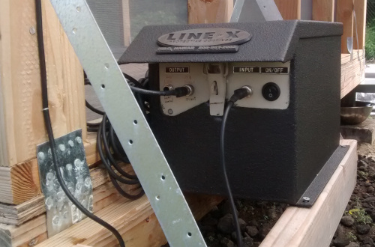

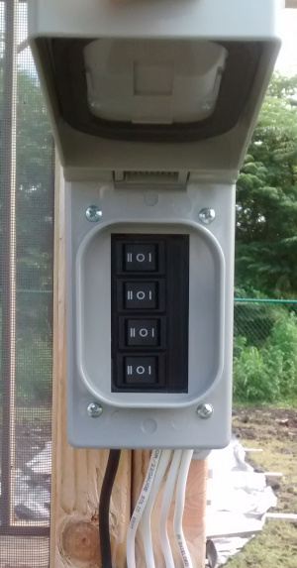

# Troubleshooting and repair

## Rotors physically loose or broken

All the plastic parts are 3D printed and therefore straightforward to replace. See the “part_designs” folder at <https://github.com/travc/olfactometer_rotor>. The aluminum parts are made from standard 1/2-inch aluminum rod (the shaft) and 3/4-inch aluminum angle (the arms).

The most likely failure points of a rotor are the coupler (connects the motor to the shaft) and the mounting assembly (aka. box).   
If there is excessive rotary ‘jiggle’, the point where the coupler attaches to the motor may be loose or worn. If tightening that connection (be careful not to overtighten though) doesn’t fix it, the gearing in the motor might be wearing out. You’ll have to take down the rotor (remove the wheel first) and disassemble the motor end to check and possibly replace the coupler and/or motor.

## Electrical

If a rotor isn’t turning but others are, the first check is to grab a voltmeter and a stepladder and check that there is 12V going into the top of the motor when it is supposed to be switched on. If that is the case, then the motor has failed or something is keeping the shaft from turning (which very likely killed the motor too). Time to disassemble it and check.

If the motor isn’t getting 12V or multiple rotors aren’t working, then the problem is likely with the power unit or switches.

## Power

The power unit (black Line-X covered box) has two 12V batteries in series, so it supplies 24V. The solar charging controller is designed for lighting and does not have a constant output, so one of the OUTPUT plugs (the one on the right side) is directly connected to the batteries instead of the controller output. That means that it will have a bit more than 24V when the unit is charging, but that is fine since the output of the power unit feeds a 15V-40V to 12V voltage converter/regulator housed in the grey box with the switches. The outputs from that grey box (the white wires running to the cages) should be a very consistent 12V.

The solar panel should be plugged into the INPUT. The left OUTPUT plug is left open, but could be connected to a light as the unit was originally intended to be used.

Is the power unit switched on?  
Has the circuit breaker tripped? Push the button above the on/off switch.  
Are the wires connected correctly? INPUT to solar panel; left OUTPUT to the grey switch box.  
Are the batteries dead? You have to open the box and check with a voltmeter for that.  
The actual on/off switch on the power unit isn’t very robust and might have failed.

## Grey switch box

The grey switch box takes ≈24V in (black wire) and 12V out (white wires). Inside is a voltage converter/regulator as well as wiring to each of the switches.

The regulator might fail, but more likely is that the wiring and custom board for the switches has failed or worse, shorted. In the case of a suspected fault, switching the power unit off should completely disconnect it, but you should unplug the black wire connecting it to the switch box as well. The wiring isn’t complicated, but it is another “open it up and check with a voltmeter” situation.